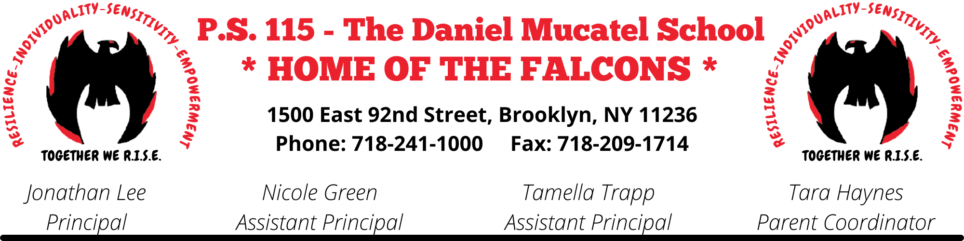
Dear Parents,

I am writing to provide you with information about the Department of Education's Emergency Readiness Initiatives that are in place in all NYC Public Schools.

Every school currently has procedures for emergencies. In 2000, New York State Education Law Section 2801was enacted requiring schools to develop safety plans regarding emergency response. In July of 2001, the law was amended to require that plans include information for evacuation and sheltering. In accordance with this, "schools need to conduct drills and other exercises to test components of the emergency response plan.

School staff members are trained in various procedures that are outlined in the School Safety Plan and we currently conduct a variety of drills throughout the year to prepare our staff and students. Section 807 of the New York State Education Law requires all schools to conduct a minimum of 12 emergency drills each year. Section 917 of the State Education Law states that schools are required to provide and maintain automated external defibrillator (AED) equipment, and drills are conducted during the year to assess the use of AED units in an emergency. In accordance with Section3623 of the State Education Law, drills are also conducted at schools that focus on safety on a school bus.

In addition, to conducting these types of drills, our school has a Building Response Team that is trained to activate and respond to different incidents that may occur at our school. Under the new General Response Protocol(GRP),every school will be conducting specific drills designed to help prepare all school communities for three different types of response to emergencies that may occur: evacuation, shelter-in, and lockdown. Opportunities for parent engagement are available at our school to ensure that families are involved in our school-based emergency readiness program. Parent versions of the School Safety Plan are available upon request in the main office, and information explaining the GRP is included with this letter. Many other important resources for families are also available by visiting http://schools.nyc.gov/Offices/OSYD/default.htm

Emergency readiness training in schools takes place in September and continues for staff and students throughout the school year. Student training is grade appropriate and designed to ensure that students understand the importance of these drills without causing unnecessary alarm. Please review the General Response Protocols that have been given to all students, and discuss these procedures with your child.

All families are reminded to update the Emergency Contact Cards that are on file in our main office. This includes providing and updating information indicating phone numbers, and the names of adults to whom the school may release children in an emergency. Families are also encouraged to register with Notify NYC (https://a858-nycnotifv.nyc.gov/notifynyc/) to receive information about emergency events, and call 311for additional information about a school during an emergency.

Sincerely,

Mr. Jonathan Lee
Principal

