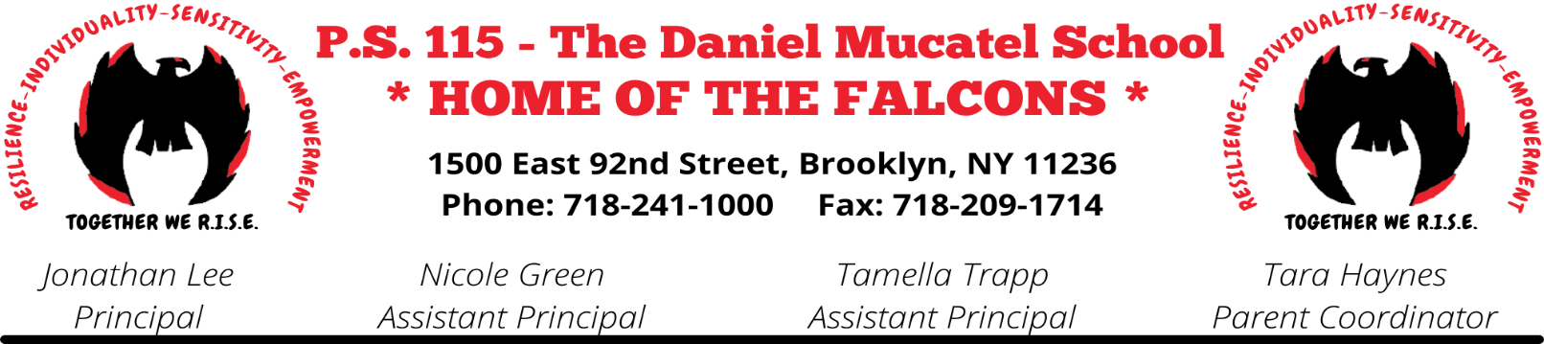
September 2023,
Dear Parents/Guardians,
In accordance with the Chancellor’s Regulations A-413, P.S. 115 will be implementing its school based cell phone policy. The policy outlines the guidelines that our school will follow in regards to the cell phone policy and other electronic devices.
Attached to this packet is:
- The Cell Phone Policy
- The Student Contract
- The Parent Contract.
BOTH the student and parent contracts must be signed and returned to your child’s teacher.
If you have any questions or concerns, feel free to contact, Ms. Haynes, parent coordinator.
Thank you for your continued support in your child’s education.

Jonathan Lee
Principal

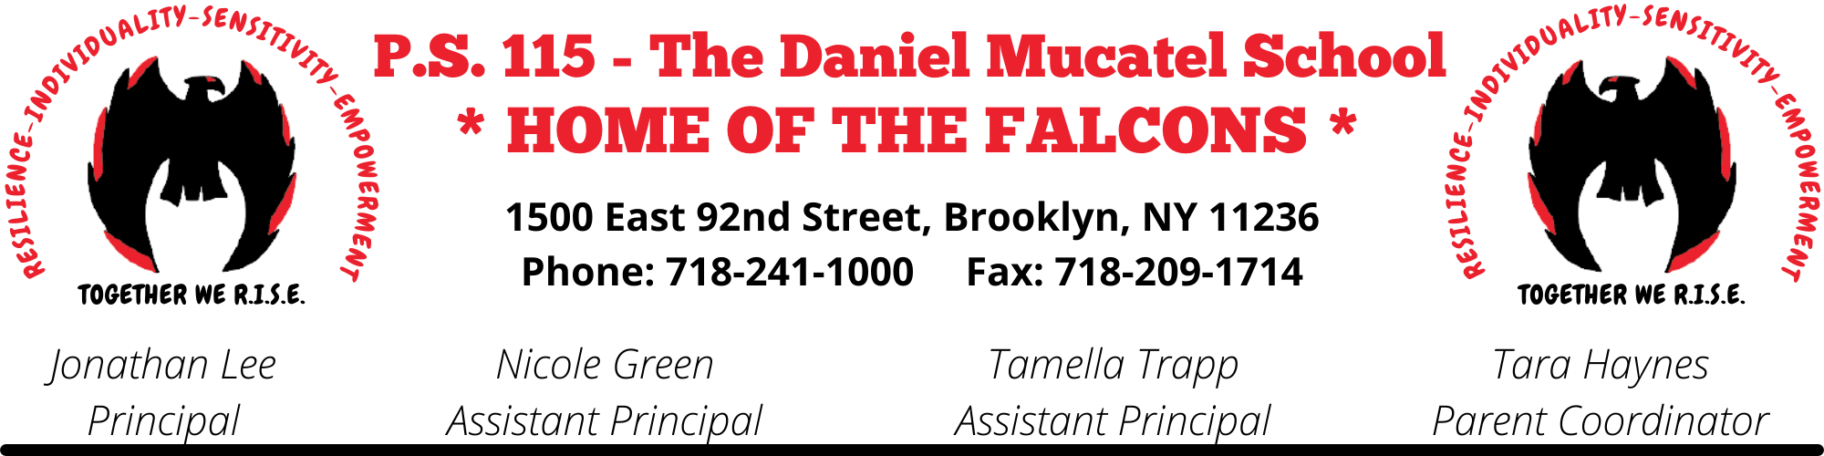
September 2023

SCHOOL-BASED POLICY OF P.S. 115, THE DANIEL MUCATEL SCHOOL, REGARDING THE USE OF CELL PHONES, COMPUTING DEVICES or TABLETS, APPLE WATCHES, AND PORTABLE MUSIC AND ENTERTAINMENT SYSTEMS ON SCHOOL PROPERTY
Students are permitted to bring the following electronic items to school:
- Cell Phones
- Laptops, Tablets, iPads, Apple Watches, and other similar computing devices
- Portable music and entertainment systems, such as iPods, MP3 players, PSP, and Nintendo DS.

- The use of cell phones, computing devices, Apple watches, and portable music and entertainment systems at school is subject to the restrictions below.
Cell phones, portable music, entertainment systems and computing devices, Apple Watches or other similar devices may not be turned on or used at any point during the school day. The school day begins at 8:00 am and ends at 2:20 pm.
All electronics brought to school must be turned off at the start of the school day, and may not be turned on until the end of the school day.
- Confiscation and return of electronic items
The following protocol will be followed in the event that a student does not adhere to the school based policy.
- First Offense: Warning
- Second Offense: Phone call home
- Third Offense: Confiscation of the electronic device and returned at the end of the school day. Parent/Guardian will also receive a phone call home.
- Fourth Offense: Confiscation of the electronic device and returned to a parent during a conference held no earlier than the next school day.
- Fifth Offense: Confiscation of the electronic device and disciplinary measure in accordance with the New York Citywide Discipline Code.
- Sixth Offense: Student will not be permitted to bring electronic device to school and subject to disciplinary measures in accordance with the New York Citywide Behavioral Expectations.

- Discipline
Any student who uses cell phones, computing devices, and/or portable music and entertainment system in violation of any provision of the DOE’s Discipline Code, the school’s policy, Chancellor Regulation A-413, and/or the DOE’s Internet Acceptable Use and Safety Policy (“ISUSP”) will be subject to discipline in accordance with the guidance interventions and disciplinary responses set forth in the Discipline Code.

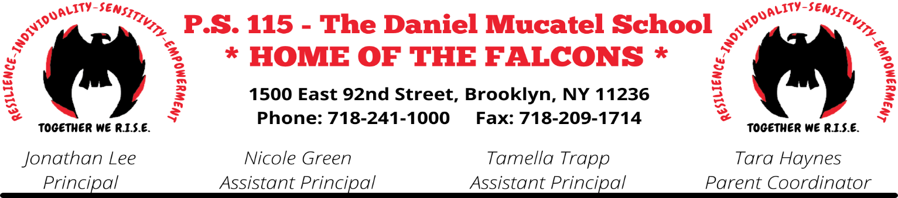
P.S. 115 Student Contract for Use of Cell Phones and Other Electronic Devices

I have read my school’s policy about use of cell phones and other electronic devices, including but not limited to Apple watches.

I know that I have a right to be:
- in a safe and supportive learning environment, free from discrimination, harassment, and bigotry;
- told by my school what is appropriate behavior and what actions may result in disciplinary actions;
- counseled by members of the professional staff when my behavior may have a negative effect on my education and/or welfare at school;
- provided with due process of law in instances of disciplinary action for alleged violation of school rules or the Discipline Code that may result in my suspension or removal from class.

I agree to:
- obey my school’s policy about cell phones and other electronic devices;
- behave respectfully, without arguing, and cooperate when a staff member gives me direction or makes a request, including to turn over my cell phone or electronic device;
- refrain from taking photos and videos of other students, staff, or school security agents without staff authorization;
- never use my cell phone or other electronic device to intimidate, embarrass, threaten, or bully others;
- never use my cell phone or other electronic device to cheat or help others cheat;
- keep my parents informed about school-related matters and make sure I give them any information sent home.

I understand that:
- I should travel to and from school using safe, familiar routes with good lighting, refrain from using shortcuts through isolated areas, and not display my electronic devices or carry them in a manner that attracts attention while traveling;
- cell phones and electronic devices may not be used during school fire drills or other emergency preparedness exercises;
- if I violate my school’s policy or the Discipline Code, my cell phone or other electronic device may be confiscated;
- if I use my cell phone or other electronic device while at home to take photos or videos of others without staff authorization, or to bully, threaten, or intimidate others, or to “text” or cheat, I will be disciplined in accordance with the Discipline Code;
- I am not permitted to charge my cell phone or other electronic device at school;
- I assume all responsibility for my cell phone and other electronic devices if I bring them to school. My school is not responsible for stolen, damaged or lost devices.

By signing this document, I agree to follow all the rules contained in this document.

Student Full Name (please print): Class: _____________

Student Signature Date: ______________

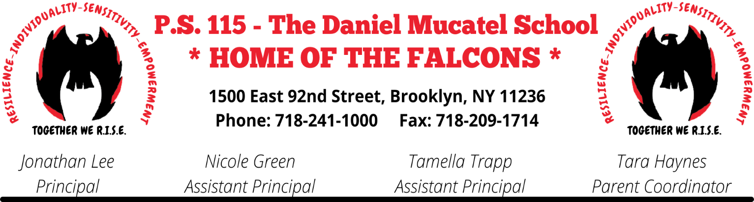
P.S.115 Parent Contract for Use of Cell Phones and Other Electronic Devices

I have read the policy of my child’s school on cell phones and other electronic devices, including but not limited to Apple watches and understand the behavior that is required of my child.

I agree to help my child follow these policies by:

- discussing with my child the contents of the school’s cell phone and electronic device policy.

- encouraging my child to be a respectful and peaceful member of the school community, and to never use an electronic device to engage in harassment, bullying or intimidation, or to take photos or post pictures of others without staff authorization;

- reminding my child that cell phones and electronic devices may not be used during school fire drills or other emergency preparedness exercises;

- reminding my child about the social responsibility of having a cell phone and understand that actions such as bullying, harassing, or sharing images of others, while using the cell phone at home is unacceptable

- calling the school if I need to contact my child during the school day and not trying to reach my child on his/her electronic device during the school day;

- teaching my child to be responsible and safe about his/her electronic devices both in school and while traveling to and from school, to not display the devices or carry them in a manner that attracts attention, to always travel using safe, familiar streets with good lighting, and to refrain from using shortcuts through isolated areas;

- reminding my child that having a cell phone or electronic device in school is a privilege, and that the privilege may be revoked, or electronic devices may be confiscated by the school if they are used in violation of the school’s policy or the New York City Behavioral Expectations.

- reminding my child that the school is not responsible or liable if his/her device is lost, damaged or stolen, that it is my child’s responsibility to take proper care of his/her device, and that devices may not be charged at school.

Student Name (please print): ____________________________________________ Class:__________________

Parent Name (please print):

Parent Signature:

Date:

